FAAC JS 48 R SECURITY BOLLARD
PROCUREMENT SPECIFICATION

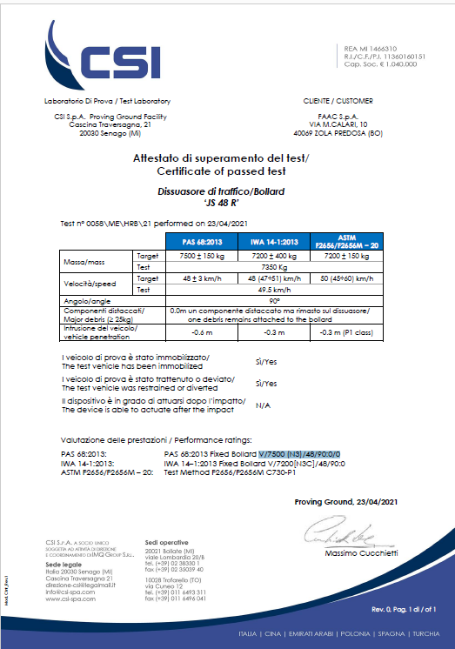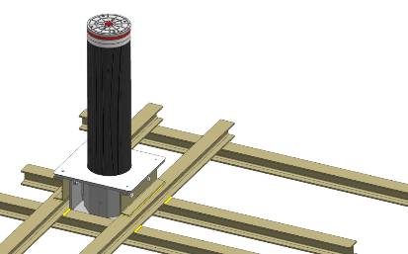

Removable HIGH SECURITY BOLLARD FAAC JS 48 R is crash tested in accordance to:
- PAS 68: Impact test specifications for vehicle security barrier systems
- IWA 14-1: Vehicle Security Barriers - Part 1: Performance requirement, vehicle impact test method and performance rating
- ASTM F2656: Standard Test Method for Vehicle Crash Testing of Perimeter Barriers

APPLICATIONS:
Delimitation of critical areas, like: military sites, airports, embassies, consulates, banks, marine zones, prisons, industrial sites or wherever is required a high level of perimeter protection.

PRODUCT FEATURES:
FAAC JS 48 R bollard has a steel cylinder 1000 mm / 40 inches high off ground, with diameter 275 mm / 11 inches.
The cylinder is protected from accidental collisions and from aggressive agents (i.e. oil spills, fossil fuels and other types of pollutants, etc.) by a replaceable jacket in mDure® polymer.
To prevent corrosion, the bollard is treated with a surface cataphoretic coating, all the internal fastenings are realized in stainless steel and the bollard’s head is coated with special Rilsan® resin.
FAAC JS 48 R bollard has to be allocated into its dedicated underground steel base. The underground support base sits within the reinforced concrete foundation realized according the supplied civil work drawings.
The riveted bars inside the cylinder allow and the correct positioning of the latter and the connection with the underground support base. By operating on the same riveted bars is possible to detach the cylinder from the underground support base and remove it, to temporarily open the passage.
The cylinder is visible from all directions, thanks to the reflecting strip and the LED lights on the head (option).

PERFORMANCE:
FAAC JS 48 R bollard is certified as capable to arrest in single unit configuration vehicles of mass 7.500 kg / 16.535 pounds, driving at ~50 kmh / 30 mph, corresponding to the following performance ratings:
PAS 68 PAS 68:2013 V/7500 (N3)/48/90:0.0/0
IWA 14-1 IWA 14–1:2013 V/7200[N3C]/48/90:0
ASTM F2656/F2656M Test Method ASTM F2656 C730-P1
The detected penetration rate is P1 (P1= highest possible rating)

AVAILABLE VERSIONS:
The cylinder aesthetic finishing can be:
- mDure® polymer protective sleeve; supplied in black colour with FAAC exclusive texture
- mDure® polymer protective sleeve; supplied with AISI 316L stainless steel cover

INSTALLATION COMPLEMENTS:
FAAC JS 48 R bollard has to be allocated into its dedicated underground support base, realized in cast iron and reinforced steel.

TECHNICAL SPECIFICATIONS:
Model | JS 48 R | JS 48 R INOX
Cylinder’s height from ground | 1.000 mm //  40 inches | 1.000 mm //  40 inches
Cylinder’s diameter including sleeve | 275 mm //  11 inches | 275 mm //  11 inches
Cylinder type | High performance steel | High performance steel
Cylinder treatment | Cataphoresis | Cataphoresis
Protective sleeve | mDure® | Aisi 316 + mDure®
Cylinder’s head | Aluminium | Aluminium
Head treatment | Anti-corrosion Rilsan® resin | Anti-corrosion Rilsan® resin
Ground cover | AISI 316 stainless steel + mDure® | AISI 316 stainless steel + mDure®
Reflective strip height | 55 mm // 2.2 inches | 55 mm // 2.2 inches
Reflective strip colour | White | White
Crash resistance | 673.000 J | 673.000 J
Cylinder weight | 180 kg // 397 pounds | 180 kg // 397 pounds
Cylinder packaging LxWxH | 1.300 mm x 300 mm x 300 mm //  51 inches x 12 inches x 12 inches | 1.300 mm x 300 mm x 300 mm //  51 inches x 12 inches x 12 inches

underground support base:
Dimensions LxWxH | 540 mm x 490 mm x 480 mm // 21 inches x 19 inches x 19 inches
Support base weight | 100 kg // 220 pounds
Support base packaging LxWxH

FOUNDATION:
Dimensions LxWxH  (foundation to allocate 2 units) | 2.700 mm x 2.300 mm x 400 mm // 106 inches x 91 inches x 18 inches*
Concrete Specifications: | Class C25/30 Concrete with 10-30 aggregate according to UNI EN 12620 standard  Bollard shall be installed after at least 7 days of concrete setting; using a proper additive, it’s possible to reduce to 3 days
Surrounding ground compacting index | ≥ 90% of the Proctor optimum curve, according to UNI EN 13286-2:2005 standard

* consider 10mm//0.4 inches above to lay the pavement + 10mm//0.4 inches below for the base of mud slab

